Natural Language Analysis

Natural Language Analysis is the initial analysis process which helps to find out the candidate class which we work on later. It is a part of analysis and it is done at first. In this process following steps are carried out:

1. First of all the selected nouns from the scenario are listed in a table.
2. Reduce the redundant nouns from the table.
3. Get rid of nouns that are improper for the system.

Here is the list of nouns for possible candidate class of the Daily expenses Management system:

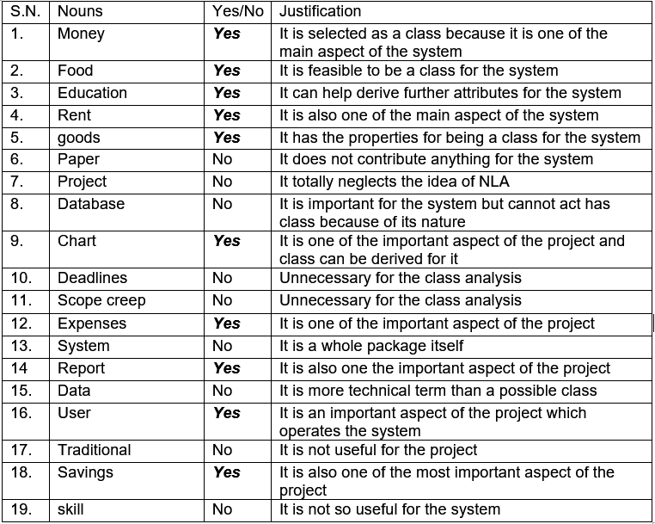

Use case Diagram

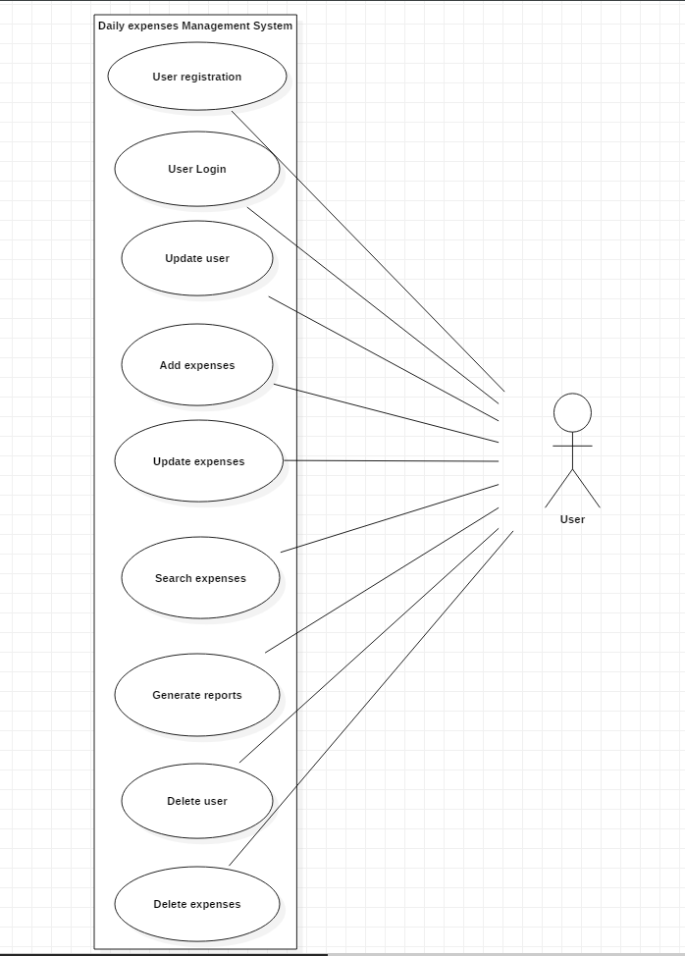

*Fig: Use case diagram of Daily Expenses management system*

The above use case diagram is the graphical representation of tasks that are done by the user. Use case diagram helps to show the tasks that are done by a user. It also shows the functionality of how the system works. Here above in the diagram we can see user registration as a use case. It is a functionality of the system that lets the user to register for their login. There is user login task that can also be done by the user. There are tasks such as update delete and other reports generating tasks that can also be done by the user. Daily expenses management system is for the single user. This project is solely handled by only one user so the use case diagram for this project has only one actor i.e. user.

Class Diagram

A class diagram is a graphical of representation of the classes that are interrelated with each other. Class diagram helps to show how each class are related with each other. The class diagram for this project is presented below:

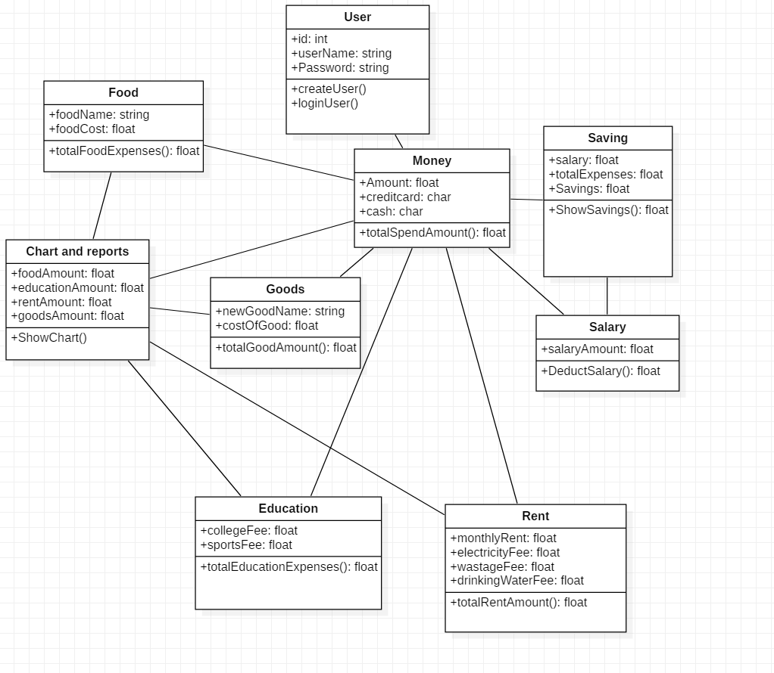

*Fig: Class diagram of daily expenses Management System*